**Printed Calendar**

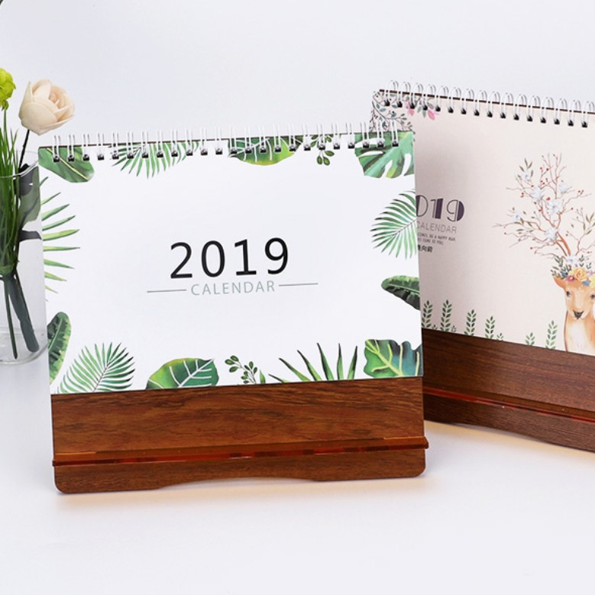

##### Rs.500/-

Popular Wooden Blocks Table Perpetual Calendar.

Beautiful, well-made Calendars are must. We take great care in selecting our products Korea and Japan in particular is where most of the stuff we offer is designed and manufactured. All our products are made with care and use high quality, non-toxic materials.

* Model Number: 2019081156
* Type: Printing Calendar
* Promotional: No
* Style: Table Calendar
* Display Screen: show as the picture
* Use: wood calendar
* Origin: China
* Color: Show as the pictures
* Size: 20.5cm x 9cm x 12cm
* Type 1: Table Calendar
* Type 2: Wooden Calendar